I Don’t Dance

Unit 5
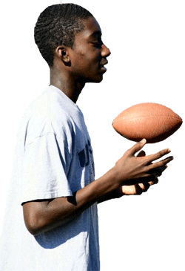
Ahh! Finally Saturday had arrived. Brian looked around his room, ignoring the dirt and clutter. He picked up his grimy football, made a cursory swipe over it with the T-shirt he had worn for the last two days to clean the worst of the dirt off, and headed for the steps. He and his two buddies, Zach and Mike, were planning to throw a football around for a while in the backyard. All three felt they had the potential to make the junior varsity squad the next year, so they wanted to practice as much as possible to improve their natural abilitities.
Brian only made it to the back door before he was halted by his mother.
“Brian, aren’t you forgetting something?” his mother asked.
“Mom, I don’t have time for that right now. The boys and I are trying to consolidate our chances for making the football team next year, so we have to practice a lot, attend all of the open practices, and keep our grades up.”
“Tryouts aren’t until next year! You are using a substantial amount of time for football, while avoiding talking about what takes place next month!”
A new family had just recently moved in beside Brian’s grandmother’s house. They had three children, and one, unfortunately, was in Brian’s grade; to make it worse, she was a girl! Plus, they came from Illinois! And everyone could tell they came from Illinois because they had that way of walking and talking like rural folk from farm country. Brian didn’t even like any of the girls in his school, much less this farm girl from Illinois. What was his mother thinking? She kept entreating him to ask this girl to the Thanksgiving dance at the middle school. She knew he didn’t like to dance – that he didn’t even know how to dance.
“Young man! You promised me you would think about it and have an answer for me this morning! Why the look of uncertainty? Can’t you just make a decision?” Brian’s mom put her hands on her hips and stared at him expecting an answer.
“Oh, Mom! You know I don’t have an iota of interest in that stupid dance. Why should I act like I do? Plus, you know the guys will never let me live it down if they find out I had to ask the new girl to the dance. In fact, it would probably be easier to be mauled – shredded, maimed, disfigured -- by a grizzly bear than face their wrath. I won’t be able to stand up for a week by the time they’re done harassing me.”
“Brian, you are so fickle. One minute you couldn’t care less what people think of you, and the next that is all you are concerned with.”
“I’m not talking about other people, Mom. I’m talking about my friends here!” Brian exclaimed.
It would be the ultimate humiliation – above and beyond any he’d suffered before -- when his friends started ragging on him. No way would they be tactful or kind when they teased him about it. He was sure they would do all of their damage in front of the whole eighth grade – and that would be the most embarrassment he’d ever endured.
“Mom, you know she is . . .” Brian started.
“Her name is Misty, Brian,” his mom chided.
“I know that!”
“Then at least give her the decency of calling her by her name,”
“Have you met Misty, Mom? I think a dead cat is less docile than she is. She is so shy and backward. We have nothing in common.” Brian was scrambling for some good reason that would get his mom off his back.
“Brian, that was uncalled for. I don’t believe that you have even tried to get to know her. She is in a new situation, so I would expect her to be a bit timid until she becomes more familiar.” Brian’s mom was becoming agitated.
Brian looked out the back door and saw that his buddies were standing in the yard staring in at him and his mother. He had to end this quickly, or they would be suspicious and ask a million questions.
“Okay – okay! I’ll ask her. I hope you’re satisfied! You may have just ruined my life!” Brian hollered as he ran out the door.
His mother smiled.
“What was that all about?” Mike asked Brian as soon as he reached them.
“Oh, nothing really. Just my mom exerting her Alpha dog status, letting me know she still dominates the household, and I still have to listen to her mandates,” Brian explained.
The boys just gave him a quizzical look.
* * *
Brian’s father put the car in drive and pulled away from the curb. They only had a ten minute trip to the florists and back; then they would pick up Misty. It was going to be a rough ten minutes though. Brian’s dad steeled himself for the barrage of questions and complaints that were sure to arise from his son.
“You know, Dad, Mom thinks that she is not fallible, but I disagree. She could be totally wrong about this girl, and I’m stuck taking her to the dance.”
“Do you mean Misty?”
“Don’t tell me you’re on Mom’s side, Dad?” Without waiting for a response, Brian continued, “And another thing. I feel like a fugitive from GQ (Gentlemen’s Quarterly) magazine in this shirt and tie. Or perhaps I just escaped from a cocktail party. Why couldn’t I have worn flannel? Huh, Dad?
“This isn’t a real tie anyway. It’s one of those kids’ clip-on ties. I’m wearing a counterfeit tie to a dance that I don’t even want to go to. You know I don’t like to dance, don’t’ you?” Brian was on a roll.
“Brian, listen to me for a minute. I’m going to tell you an anecdote about how your mother and I met. I think it will help to put this in perspective for you and calm your nerves a little,” his dad stated.
Brian’s dad continued explaining how his friends had felt they had to tamper with his social life since he couldn’t seem to form one on his own. They arranged for a blind date one weekend but didn’t tell him about it. They only told the girl. His dad went thinking he was just going with friends, but realized when he arrived that the number of girls and buys was equal. He was very upset until they introduced him to Brian’s mother.
“The rest is history!” his dad added.
“You think I’m going to meet my future wife!” Brian exclaimed, horrified by the idea.
“No, no! Misty may just surprise you. That’s all I’m saying.”
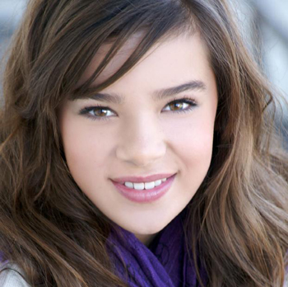
* * *
Brian trudged up to the door and rang the doorbell. The front door slowly opened. Brian’s jaw dropped. Standing in the doorway in an aura of angelic light was the most radiant human being Brian had ever seen.
“Misty, my mom and dad were right,” Brian blurted.
Misty smiled and asked, “What were they right about, Brian?”
“That I might be in for a big surprise.” He smiled. “Let’s go dance!”

UNIT 5 - VOCABULARY
WORD | DEFINITION in your own words from context clues | MEMORY TRIGGER
grimy
potential
consolidate
substantial
rural
entreat
uncertainty
iota
maul
fickle
ultimate
tactful
docile
dominate
fallible
fugitive
counterfeit
anecdote
tamper
radiant

