Squirrel!!!

Unit 6
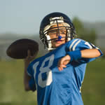
When Brian picked himself up off the ground, he swore to himself he was going to heap an ugly vengeance on Mike for that cheap shot. Just when Mike’s mom had called Brian’s name, and he had turned to listen to her, Mike had let fly a pass of NFL quality that caught Brian square on the side of his head.
“You’re going to pay dearly for that, Mike,” Brain yelled at his buddy.
“If you didn’t have such marginal skills when it comes to catching a football, you would not have gotten smacked in the side of the head. That’s why you sit on the sidelines during the games,” Mike retorted.
“Your mom was calling me!” Mike’s attitude was beginning to frustrate Brian. Couldn’t Mike see that his focus had been interrupted by the yelling of his name?
“Do you think NFL receivers lose focus every time their names are hollered?” Mike was really trying to push Brian’s buttons.
“Oh, just stuff it, Mike,” Brian growled as he walked over to Mike’s mom.
Mike was a bit reluctant to follow him. He knew his mother would not be impressed with his passing prowess, so he hung back just out of earshot.
“Brian, your grandmother called. She would like you to come home immediately. It seems a squirrel has climbed into the fireplace chimney, and she wants you to help her snare it. She said you are quite good at trapping animals,” Mike’s mom explained.
“Cool! Do you think Mike could come along and give me a hand?” Brian asked.
“You would invite him after the stunt he just pulled? That’s quite a prominent shiner you have on the side of your head. That bump sticks out like a sore thumb!”
“Ah, that’s nothing. We do this to each other all the time. This lump is just a preview of what is going to happen to Mike when I seek my revenge. His lump is going to be ten times as big,” Brian retorted proudly.
Mike’s mom could not help laughing. These boys just filled her with so much joy. “How do you plan to dupe Mike into not recognizing this pending smack down?”
“Oh, not to worry. I have my ways of tricking him and sneaking up on him.”
They both laughed.
* * *
“Hey, Grandma!” We’re here to eradicate that pesky varmint you have cornered in the chimney,” Brian yelled through the back door.
“Great! That little pest has turned my quaint little sitting room of antiques into a mad house with all the noise it’s making up in that chimney.”
Brian believed he knew exactly what course to prescribe to lure the squirrel out of the chimney. He planned to start a smoky fire, which would certainly drive the squirrel up and out the top of the chimney.
“Hey, Mike. Go browse through those papers over there and pick out the oldest ones,” Brian directed Mike.
Brian had just recently read about this very problem on the Internet. It involved a bird, not a squirrel, but there couldn’t be that much difference. Unfortunately, the person who posted the story had decided to remain anonymous, so Brian could not contact the unknown person to ask a couple of questions. Oh well, they would just have to devise a makeshift plan from the limited information on the site.
Brian started to gather some firewood from the wood pile in the corner, while he had Mike dampen some of the newspapers so they would smoke more. He wanted as much wood and newspapers as he could find; he didn’t want to scrimp on heat or smoke – the two necessities for driving the squirrel out.
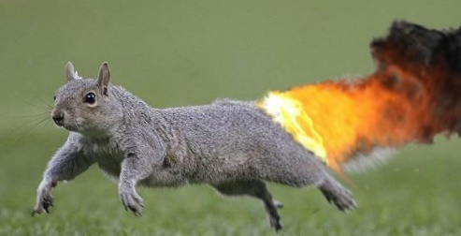
The only part Brian hadn’t figured on, though, happened almost immediately after they had the fire heated up and smoking well. The squirrel ran out of the fireplace instead of climbing out the top of the chimney. Plus, from dropping onto the burning logs, its tail had caught fire.
As the squirrel jumped out of the fire, Brian thought the situation could not become any more grim than it already was. Then the squirrel ran toward the floor-length curtains with its tail ablaze.
“Mike, open the back door quickly!” Brian yelled.
Mike flung the door open, and Brian did his utmost to corral the flaming squirrel toward the open door. The squirrel was putting on quite a show. Brian could just see the headlines in the paper: “Flaming Squirrel Sets House Ablaze during Dynamic Escape Attempt.”
Finally, with the use of a few couch cushions, Mike shooed the squirrel out the door and into the yard where the flaming tail extinguished.
Brian’s grandmother stood in the yard, bent over with her hands on her knees, laughing uncontrollably.
“Now this will be an inimitable tale to tell your grandchildren. No one’s ever heard a story like it. They will surely believe it because you just can’t make this kind of stuff up.”
--Ron Powers
UNIT 6 VOCABULARY
WORD | DEFINITION in your own words from context clues | MEMORY TRIGGER
vengeance
marginal
frustrate
reluctant
snare
prominent
preview
dupe
pending
eradicate
quaint
prescribe
browse
anonymous
makeshift
scrimp
grim
utmost
dynamic
inimitable

