Crash Course

Unit 7

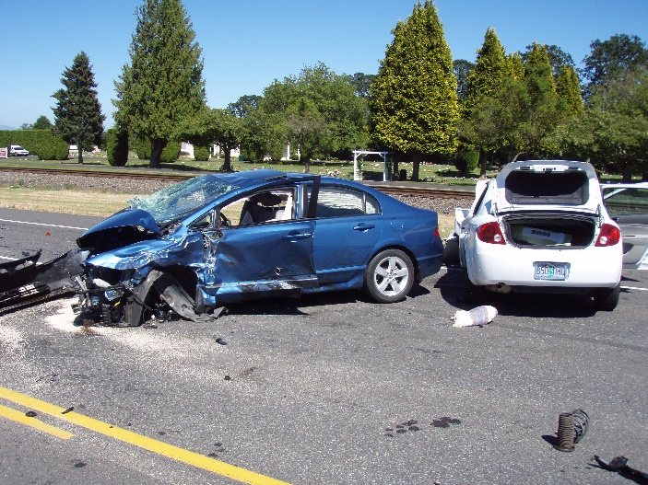
As Brian’s dad began to accelerate when the light turned green. Brian looked to his right because he had noticed movement in his peripheral vision. The movement gave him the feeling that something was amiss. Before he could shout a warning to his dad, a car came careening through the red light and slammed directly into the side of the car where Brian was strapped in.
The momentum of the other car was so great that it pushed their car across both lanes of traffic, only stopping when their car hit the far curb. The popping sound of the airbags sounded like a cannon salvo being touched off at a Civil War reenactment. It took Brian several seconds to regain his bearings. When he did, his foremost concern was whether his dad had been injured.
“Dad, are you okay?” Brian yelled.
“Yes, I’m fine. Just relax. I think everything will be okay. Are you hurt at all?” Jeff didn’t want Brian to become flustered and try to jump out of the car in a panic and end up getting hit by another car.
“Unbuckle your seatbelt, and we will both exit on my side, out of the traffic,” Jeff instructed Brian.
As Brian and Jeff exited their car onto the sidewalk, they both were confused by the commotion coming from the other side of the car. When they walked to a spot where they could see what was going on, they both stood with their mouths agape. The two people who had been in the other car were standing nose to nose and toe to toe and were involved in a verbal brawl that emanated such wrath that the anger was almost visible.
Brian assumed by the couple’s age that they were husband and wife, so their domestic argument that appeared as if they both detested each other really sent him for a loop. His mother and father would never argue with each other like that, even in private.
“Dad, do something before they begin to actually fight and someone gets hurt,” Brian bawled.
“Brian, I don’t think we should interfere at the moment. I know the situation, and my inaction may seem like a paradox to you, but it is not always wise to interfere where you are not wanted, even if someone may get hurt,” Jeff explained.

“Dad, I think you are wrong. I may be young, but I’m no fledgling who has never witnessed an argument about to become physical. For you to presume that their argument will just fizzle out is a flagrant disregard for all the signs I am seeing that just the opposite is going to happen,” Brian stated with all the force of purpose he could muster.
“Well, what are the notable signs that would lead you to your current decision to interfere -- as opposed to my prior decision to not interfere?” Jeff asked.
“Look at his face, Dad. It’s totally red, and the veins are bulging out on his forehead and neck. Also his stance indicates that he is about to throw a punch. Add that to the fact that both of his hands are clenched into fists, I would say that he is definitely about to become physical. And she is being very vigilant as if she is expecting the very same thing -- almost like this wouldn’t be the first time.”
Jeff turned to Brian, “I see no flaw in your assessment.” He stepped between the couple and stuck his hand out to the man.
Jeff knew that what he was about to say would be labelled as perjury in a court of law, but lying was the least of his concerns right now.
“Hi, my name is Jeff, and this is my son, Brian. Neither of us were injured, and it appears that neither of you were either. I know you are both feeling bad about this and are obviously discussing how to make it right, but right at this moment, we are just extremely relieved that neither of you are injured. I have already notified the police, so they should be here any second to sort everything out.”
With the mention of the police, the man’s anger de-escalated very rapidly. Brian even noticed the tension leave the woman’s body. Brian watched in amazement then as his father, using words and gestures, began to nurture both back to a state of calm and compassion, like a mother calming her baby.
Brian had never been more proud of his father. He had witnessed other amazing events in his life, but the proficient and caring way that he handled these two adults, who were on the edge of great regret, just made his heart smile. His dad had just given him a crash course in loving others.

--Ron Powers

UNIT 7 VOCABULARY
WORD | DEFINITION in your own words from context clues | MEMORY TRIGGER
amiss
momentum
salvo
foremost
fluster
brawl
wrath
domestic
detest
paradox
fledgling
presume
flagrant
notable
prior
vigilant
flaw
perjury
nurture
proficient

