Albert Einstein’s Riddle

Name_____________________________________Date________________________________

Albert Einstein said that only the top 2% of intelligent people in the world can solve this riddle. Can you?

- On a street, there are five houses, painted five different colors
- In each house lives a person of a different nationality
- These five homeowners each drink a different kind of beverage, smoke a different brand of cigar and keep a different pet

THE QUESTION: What is the order of the houses? Which homeowner lives in each house? What does each homeowner smoke and drink?

Hints:
- The Brit lives in a red house
- The Swede keeps dogs as pets
- The Dane drinks tea
- The green house is next to and on the left of the white house
- The owner of the green house drinks coffee
- The person who smokes Pall Mall rears birds
- The owner of the yellow house smokes Dunhill
- The man living in the center house drinks milk
- The Norwegian lives in the first house
- The man who smokes Blends lives next to the one who keeps cats
- The man who keeps horses lives next to the man who smokes Dunhill
- The man who smokes Blue Master drinks beer
- The German smokes Prince
- The Norwegian lives next to the blue house
- The man who smokes Blends has a neighbor who drinks water

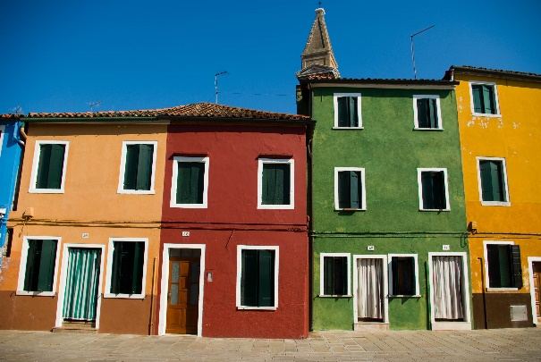
WHO ARE THEY?

Who is Who?

 | House 1 | House 2 | House 3 | House 4 | House 5
Color
Nationality
Beverage
Cigar
Pet

