The Theft at the Art Museum

The theft of several valuable paintings from the Royston Art Museum created a sensation throughout New England. Two days after Stanwick’s return from a visit to Scotland, he was visited by Inspector Matt Walker, who was in charge of the case. As Stanwick poured tea, Walker quickly brought his friend up to date on the case.
“We’ve identified the gang of five thieves who must have done this job,” Walker reported. “Archie McOrr, who never finished high school, is married to another one of the five, Charlayne Trumbull. The other three are Beverly Cuttle, Ed Browning (also never finished high school), and Douglas Stephens.”
“I thought you told me earlier that only four people were involved in the robbery,” said Stanwick.
“That’s right. One stayed in the car as the driver, another waited outside and acted as lookout, and two others entered the museum and carried out the actual theft. One of the five gang members was not involved in this particular job at all.”
“And the question, I hope,” said Stanwick with a smile, “is who played what part, if any, in the theft.”
“Exactly.” Walker flipped open his notebook. “Though I’m glad to say that our investigation is already bearing some fruit. For example, we have good reason to believe that the lookout has a Ph.D. in art history, and that the driver was first arrested less than two years ago.”
“A remarkable combination,” Stanwick chuckled.
“Yes, indeed. One of the actual thieves (who entered the museum) is the sister of Ed Browning. The other thief is either Archie or his wife.”
“What else do you have on Douglas?”
“Not much. Although he’s never learned to drive, he used to be a security guard at the Metropolitan Museum of Art in New York.”
“Interesting. Please go on.”
“The rest is mainly odds and ends.” Walker thumbed through a few more pages of notes. “Charlayne, an only child, is very talented on the saxophone. Beverly and Ed both have criminal records stretching back a decade or more. We’ve also learned that the driver has a brother who is not a member of the gang.”
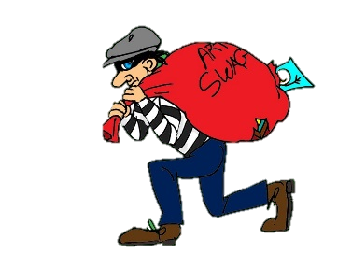
“Most interesting indeed,” remarked Stanwick. He handed Walker a mug of tea and sat down with his own. “Your investigation has made excellent progress. So much, in fact, that you already have enough to tell who the thieves, the lookout, and the driver are.”

WHO ARE THEY?

Whodunit?

GANG MEMBERS | Thief #1 | Thief #2 | Lookout | Driver
Archie
Charlayne
Beverly
Ed
Douglas

