BOOK CLUBS

BUILDING YOUR BOOK CLUB
To plan how to negotiate the planning of book clubs

CONVERSATIONAL WARM-UP: Membership grid
GOAL: to practice the same focusing and questioning that is necessary for an in-depth discussion about a book.
Students begin with a blank Membership Grid. The date and interview topics are recorded on the left and the group members’ names on the right above the columns. Group discuss a different topic each time they use the grid. The group takes one minute to interview each member in turn. As the group conducts each interview, the members take notes on each person’s answers. The goal is to ask the interviewee enough questions about the topic to elicit some interesting details, which members then write on their grid. In the column under their own name, students may either jot notes on what they said when they were interviewed, or write some of the questions they asked when they interviewed the others.
TOPICS | GROUP MEMBERS
Use the full minute to interview each classmate. Make sure to ask questions based on the previous answer.
Ask questions that do not require only a yes / no answer.

BEFORE I READ
What the text tells me BEFORE I read:
- Who is the author? What do I know about this author?
- When was it written? Is that important?
- What is the title? What does that suggest?
- Are their chapter titles?
- Is there vocabulary I need to know?
- What does the summary tell me?
- Is there a hint to the theme already? Can I make a guess?

WHat is theme? – Somebody… wanted… But… So…
READING RESPONSE SUGGESTIONS
READING RESPONSE SUGGESTIONS
(Note: Do NOT summarize the text)
Your Reader’s Notebook is a place to record your reactions and questions. Take risks and be honest.

- State your feelings, thoughts, reactions, and questions about situations, ideas, actions, characters, settings, symbols, plots, themes, and any other elements in the story.
- Write about what you like and dislike, what seems confusing or unusual to you.
- Tell what you think something means.
- Make predictions about what might happen later.
- Relate your personal experiences which connect with the plot, characters, or setting.
- Select an important quote from the story (one to three sentences), explain how you connected to the quote, and show how the quote relates to the theme, conflict, or character in the text.
- Choose a minor character and show how he or she was important to the plot, main character, or themes.
- Select three key events and show how each provided insight into a character’s personality.
- What emotions did the section invoke: laughter, tears, smiles, anger? Why?
- Sometimes books touch you, reminding you of your own life, as part of the larger human experience. What connections exist between the book and your own life?
- What would you like to change about one of the characters? Why?
- Does the book leave you with questions you would like to ask? What are they? What questions would you like to ask the author? A character?
- Is there an idea in the book that makes you stop and think, or prompts questions? What?
- What are your favorite lines, quotes? Copy them and explain why they caught your attention.
- How have you changes after reading the book? What did you learn that you never knew before?
- How does the title connect to the book? The theme?

NOTE and NOTICE LESSONS
Teach students to find theme by looking for the following signposts:

AHA MOMENT
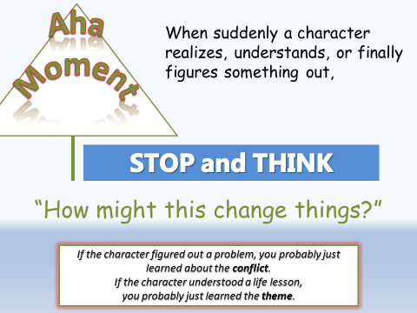

Words of the wiser
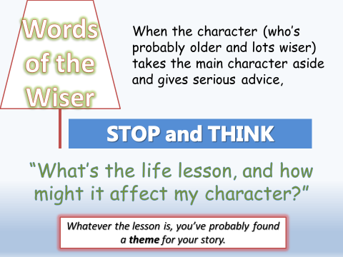

Again and again
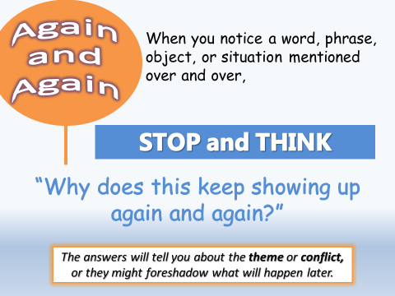

memory moment
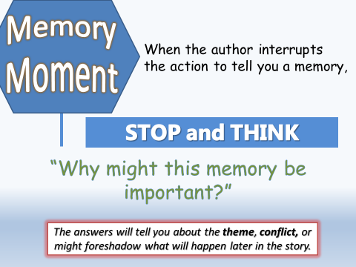

Save the last word for me
Choose two passage of text that do not require extensive introductions (like the opening passages of novels). Make sure students have copies so that they can read along. Model the first passage the way the kids do: Read it aloud then immediately explain in detail why you chose it.
From To Kill a Mockingbird by Harper Lee
When he was nearly thirteen, my brother Jem got his arm badly broken at the elbow. When it healed, and Jem’s fears of never being able to play football were assuaged, he was seldom self-conscious about his injury. His left arm was somewhat shorter than his right; when he stood or walked, the back of his hand was at right angles to his body, his thumb parallel to his thigh. He couldn’t have cared less, so long as he could pass and punt.
When enough years had gone by to enable us to look back on them, we sometimes discussed the events leading to his accident. I maintain that the Ewells started it all, but Jem, who was four years my senior, said it started long before that. He said it began the summer Dill came to us, when Dill first gave us the idea of making Boo Radley come out.
Teacher’s Explanation: I chose this passage because it makes me ask a lot of questions. How did Jem’s arm get broken? Why are they still talking about it years later? What does Jem’s arm have to do with Boo Radley? What does it mean that Dill made him come out” Why was he hiding? Why did they even care about him? Who are the Ewells? It sounds like the narrator blames them for Jem’s broken arm. Considering that Jem’s big concern was playing football, it seems like it’s the narrator who can’t stop thinking about his incident rather than Jem. He seems okay with it. That word “assuaged” is interesting. I wonder what it means.
Then you might say, “Okay, that’s what I think. Let’s get some ideas from some other readers,” and call on a few kids at random. Probably no one will have anything to add.
Before reading the second passage, say that you want them to follow along and notice what the passage makes you think about. After hearing the passage, everyone should be ready to have something to say about it.
After reading the second passage, explain the new strategy, “Now we’re going to Save the Last Word for Me. Before I say anything about this passage, I want to hear what some of you have to say. Tell the rest of us why you think the passage was important, how that passage relates to something else in the story, or just what you noticed and thought about as that passage was read. Then call on three or four kids at random before you explain why you chose it.
Students should notice that it’s easier to think of a response before the reader explains anything and that their ideas are often different from the readers.
Now explain that whenever someone reads a passage aloud, the only thing the reader can say at first is “Save the Last Word for Me.” Not until everyone else has contributed some opinions can the person who chose the passage explain his thoughts.

Dealing with slackers
(attached)

REREad to lift a line
Good readers miss details so they reread.
Ask kids to reread and find a spot where they find a detail or moment that they had missed in their first read and rewrite that line on a notebook page. Students then write about how that detail or moment helps them derive more meaning from the story or text.
“You’re so lucky. You get to reread and discover all of the clues and moments you missed the first time you read this. This is called “Second-draft reading.” It’s helpful for me to write in my reader’s notebook about eh thinks I want to share with you the next day. I lift that line. First I write the line from the book that sparked my thinking. When I rewrite the line exactly, I’ll put it in quotes and write the page number. This is lifting a line—I’m taking a line right our]t of the book so I can write about it. Beneath this, I’ll write my thinking about this part and how it has me thinking about the book.”
“Love” or “Dr. Jekyll and Mr. Hyde”

NOTICING THE FEELINGS
We are going to begin to practice noticing what a writer does in our reading. We want to record the parts that take our breath away, make us laugh, or make us cry. These are parts of a story that we want to reread and figure out how the writer did that. Because it is from here that we can start thinking about how we can make our own readers lose their breath, laugh out loud, or even cry.
Hand each child a copy of the passage from Maniac Magee by Jerry Spinelli. Have them glue them into their readers’ notebook. Read the passage aloud with the students reading along silently and listening. Then read the text again. This time, ask the students to begin marking the passage where they like the way the author wrote about something. Then give them time to read the passage silently a third time, and to mark it up with their highlighters, pens. . . Discuss.
Give the students instructions for making this a habit:
- Stop yourself when you have read a really great part of a book.
- Go back and reread the same part two or three times.
- What do you notice the writer did to help you enjoy the piece as a reader?
- Record this in your reader’s notebook as you read.
(attached)

READER’S NOTEBOOK RUBRIC

READER’S NOTEBOOK RUBRIC
Criteria | 5 points | 3 points | 1 point
Variety | Student has used a variety of notebook and comprehension strategies. | Student has tried different notebook strategies but tends to use only strategies the teacher requests | Little to no attempt is made to try different strategies, but tends to use retelling and summary instead of reaction.
Volume | Entries are all at least one page long. | Entries vary in length. | Most entries are half page or less.
Thoughtfulness | Entries are reflective and reveal new understandings about the text. | Entries are thoughtful and demonstrate use of different comprehension strategies. | Entries show nothing but the retelling of the story line.
Organization | Entries are organized in a manner that is useful to the reader. Use of paragraphs and logical order of ideas. | Entry organization seems haphazard, skipping from one idea to the next. Little explanation supports new ideas. | Ideas in an entry are not organized. No paragraphing is used.
Frequency | Student has written at least two entries per week. | Student has written at least 70% of required entries. | Less than 70% of required entries are completed.
Grammar | Student is careful to always use proper capitalization, spelling, grammar, and punctuation. | Student has made a few errors in capitalization, spelling, grammar, and punctuation. | Entries are riddled with errors in capitalization, spelling, grammar, and punctuation.

