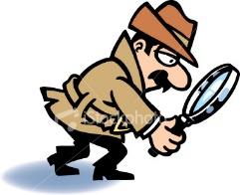
Murder Witnesses

Name_____________________________________Date________________________________

Sherlock Holmes was questioning three men who had been witness to a murder – Mr. Franks, Mr. Richards, and Mr. Andrews. By coincidence, their first names were Richard Frank, and Andrew. Holmes remarked to Mr. Richardson this.
“Yes, I noticed that as well,” he replied. “But none of us has the first name that matches our surname. My first name happens to be Andrew.”

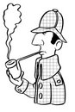

WHO ARE THEY?

Who is Who?
Find the first and last names of each man.

 | Franks | Richards | Andrews
Richard
Frank
Andrew

Escape by Train

Sherlock Holmes and Dr. Watson were following three criminals who had carried out a bank robbery to Euston railway station. Unfortunately, all three had managed to escape before Holmes and Watson arrived at the station. Holmes interviewed several railway employees and discovered that all three had boarded trains to different destinations. Parker, the leader of the trio, did not take the train to Carlisle. Davidson didn’t take the Liverpool train, and Costello didn’t take the Glasgow train. He also discovered that the Carlisle train left the station before the train taken by Davidson. Holmes knew that each of the three had taken a train to one of the above-mentioned destinations.

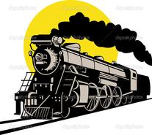

What is the destination of each criminal?

 | Carlisle | Liverpool | Glasgow
Parker
Davidson
Costello

