PLANNING YOUR PROJECT
- Decide upon your final goal -- what the project should look like at the end. You may even wish to draw a picture or write a few sentences to describe this goal.
- Brainstorm various steps you will have to take in order to reach this goal. For a book report, these steps might include choosing a book, reading the book, thinking of a topic to write about, writing the report, revising the report and creating the report cover.
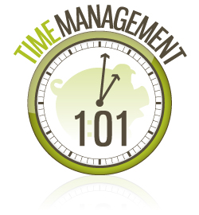
- Write each of these steps down, then post them on your calendar in order, leaving enough time to complete each step.
- Consider what obstacles might come up, and how you will overcome those obstacles. Make sure you have enough time built in to your schedule to deal with these obstacles. For example, what if no computer is available on the day that you selected to create your final presentation?
- Choose an accountability partner to meet with regularly to discuss how you are progressing. Do you feel you left yourself enough time for each step, and have you accounted for all possible obstacles?
- When you have completed the project, ask yourself to think about what part of the planning process worked best for you, as well as what you learned from the process for next time.

Tips & Warnings
- It can help for some people to sketch out what the project will look like when it is completed, so they can visualize their goal.
- Some people have a difficult time remembering to carry out each step of the project, even once they've planned it out. If this is you, brainstorm ways to remind yourself that it’s time for each step, such as setting a cell phone alarm, writing it in your planner or putting a sticky note in a strategic location.

