Robberies on the Block

Name________________________________________________Date____________________________

Aston Avenue was a private row of only five houses numbered 1, 2, 3, 4, and 5. The owners of these houses were Mr. Jones, Mr. White, Mr. Smith, Mr. Green, and Mr. Brown. All five houses had recently been robbed, and Sherlock Holmes called to speak with each of the owners. Unfortunately, all five were not at home. Holmes spoke with a passerby and was able to record the following facts:

- Jones lived two doors to the left of Smith.
- Brown and Green living to Smith’s right.
- Both White and Grown lived in an even-numbered house.

From the above information, can you determine in which house on Aston Avenue each man lived?

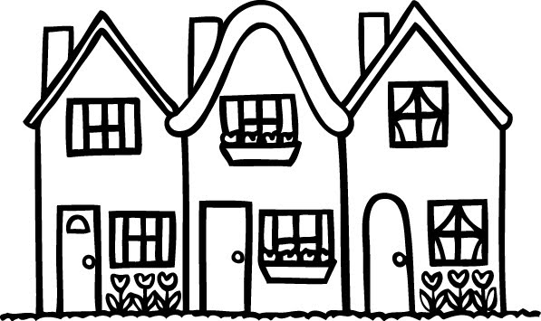

WHO LIVES WHERE?

WHO LIVES WHERE?

 | No. 1 | No. 2 | No. 3 | No. 4 | No. 5
Mr. Jones
Mr. White
Mr. Smith
Mr. Green
Mr. Brown

