Stop the Escape

Name________________________________________________Date____________________________

While serving a prison sentence in Wormwood Scrubs Prison, Professor Moriarty made five separate escape attempts on each day from Monday to Friday. On each attempt, he tried a different method:
- Disguised himself as a prison officer
- Tried to tunnel from his cell
- Attempted to bribe a prison officer
- Exchanged identity with a visitor
- Attempted to sneak out with a work party

From the following information, can you determine which method was used on which day?

- Moriarity attempted to escape disguised as a prison officer two days before his attempted bribe of a prison officer.
- He tried to tunnel out of his cell the day after his attempt disguised as a prison officer.
- His attempt to sneak out with the work party didn’t take place on Monday or Friday.
- Moriarty exchanged identity with a visitor the day after his attempt to join the work party.

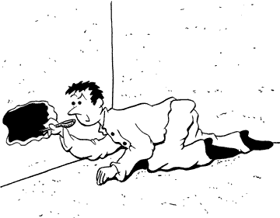

Stop the Escape!
 | Monday | Tuesday | Wednesday | Thursday | Friday
Disguised
Tunneled
Bribed
Exchanged identity
Sneaked with work party

