SYLLABUS for 8th GRADE

LANGUAGE ARTS

with MRS. POWERS



***B****ooks, I found, had the power to make time  
stand still, retreat or fly into the future.*~ **Jim Bishop** ~

**READING**

Reading is essential for future success. We will be reading short stories and novels, mysteries, horror, adventure, realistic fiction, historical fiction, literary nonfiction, informational nonfiction, poetry and more. Reading is a never-ending journey of growth and learning. Our goal for each student is to read 30 books this year, but it is required that they read about 100 pages each week – that’s just 20 pages each school day (or about 30 minutes of reading). Students will have a great deal of choice in the novels they read.



**WRITING**

***W****riting became such a process of discovery that I couldn’t wait to get to work in the morning: I wanted to know what I was going to say.*

~ **Sharon O'Brien** ~

In today’s workplace, the greatest complaint of employers is the inability of employees to write. We will focus much of our time this year on writing. We will be writing creative pieces, paragraphs, essays, research papers, and poetry. Please expect to be working on some writing piece at all times throughout this school year.

We will focus on the writing process: prewriting, drafting, revising, editing, and publishing and various traits of writing, including focus, organization, voice, word choice, sentence fluency, conventions, and presentation.

We will spend time securing our knowledge of grammatical conventions so as to produce quality works of writing. Since we are looking for quality writing, writing will be scored on an “A” or “NY” scale. We are looking for writings to be a quality “A” piece of writing, therefore until each writing meets the “A” criteria on the rubric, the piece will be scored with a “NY” or “Not Yet.” Each piece of writing may be revised, edited, and rewritten as many times as necessary to achieve the quality “A” for which we are reaching.



***W****ords, so innocent and powerless as they are, standing in a dictionary, how potent for good and evil they become in the hands of one who knows how to choose and combine them.*

**VOCABULARY**

~ **Nathaniel Hawthorne** ~

It seems almost impossible to overstate the power of words; they literally have changed and will continue to change the course of world history. Perhaps the greatest tool we can give students for succeeding, not only in their education but also more generally in life, is a large, rich vocabulary and the skills for using those words. Our ability to function in today’s complex world is mightily affected by our languages skills and word knowledge. For this reason, we will have vocabulary exercises to complete daily, and we will be working with our vocabulary words daily in class. Our goal is not to memorize words for a quiz but to internalize them and make them our own. In addition, we will focus on learning vocabulary skills such as using context clues, recognizing word parts (Latin and Greek prefixes, suffixes, and root words), discerning multiple meaning words, and the dreaded homonyms and other easily confused words.



**SPEAKING and LISTENING**

***C***[*ourage is what it takes to stand up and speak; courage is also what it takes to sit down and listen.*](http://www.brainyquote.com/quotes/quotes/w/winstonchu161628.html)~ [**Winston Churchill**](http://www.brainyquote.com/quotes/authors/w/winston_churchill.html) ~

Businesses today are looking for employees who have excellent communication skills. They need to be able to share ideas clearly and enthusiastically, and they need to be able to listen to others and offer constructive criticism. We will be practicing these skills daily in the form of pairs, table groups, and whole class presentations. Although many say that public speaking is the number one fear in America, it is a fear that must be overcome for success in today’s society. We will be working toward overcoming that fear this year.



***A*** *man who does not think for himself does not think at all.*~ [**Oscar**](http://www.brainyquote.com/quotes/authors/w/winston_churchill.html) **Wilde** ~

**THINKING and**

**PROBLEM-SOLVING**

**SOCRATIC SEMINAR**

Using **Genius Hour** – one class period each week in which students choose their own problems to solve – and **Socratic Seminar** – a time set aside for students to discuss controversial topics in a controlled conversation – students will improve their thinking and communication skills.

**GENIUS HOUR** – During Genius Hour students will be provided with one class period (90 minutes) each week to work on their own passion projects. Students will choose a problem to solve, research for answers, create a product, and share their journey through blogs and presentations.

**SOCRATIC SEMINAR** – These discussions provide a place for students to study a controversial topic or text. Within the context of the discussion, students listen closely to the comments of others, thinking critically for themselves, and articulate their own thoughts and their responses to the thoughts of others.

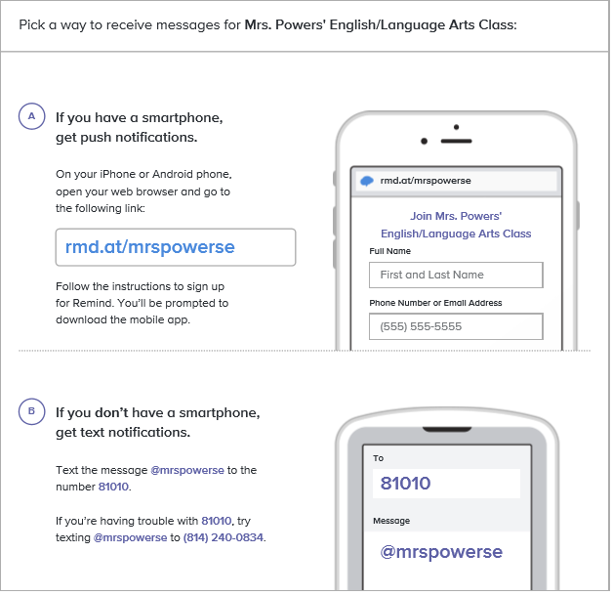

**WAYS TO CONNECT WITH MRS. POWERS**

**Email is the quickest way to reach me:** [**bpowers@gcasd.org**](mailto:bpowers@gcasd.org)**.**

**Please use my website for lessons, papers, and communication:** [**https://bethpowers.weebly.com**](https://bethpowers.weebly.com)

**And register for daily text messages for homework and other due dates**