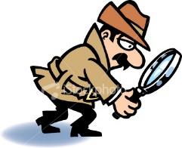
Plot the Arrivals

Name________________________________________________Date____________________________

Dr. Watson, who had been keeping an eye on events at Lady McBride’s dinner party, reported back to Sherlock Holmes at 221b Baker Street.
“I need to know the arrival times of the guests, Watson,” said Holmes.
Watson glanced at his notepad. “Yes, here it is. The arrival times are as follows,” said Watson. “7:30. 7:45, 7:50, 7:59, 8:05, with the last guest arriving at 8:20.”
“Very good, Watson,” said Holmes. “But I need to know just exactly which guest arrived at which time.”
“Oh,” said Watson, somewhat embarrassed. “I didn’t write that down, Holmes.”
Eventually Watson was able to pass the following information to Holmes:

- Lady Barclay, who wasn’t the first to arrive, arrived before Lord Hadden.
- Sir Harry Trump arrived fifteen minutes after Lord Winterbottom.
- It was one of the ladies who arrived six minutes after Sir John Penn.
- Lady James arrived fifteen minutes before Lord Hadden.

From the information, can you deduce the exact arrival time of each of the six guests?
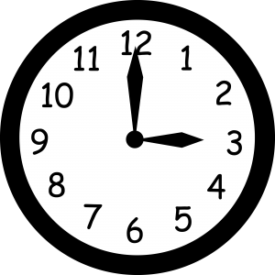

WHAT TIME IS IT?
 | 7:30 | 7:45 | 7:50 | 7:59 | 8:05 | 8:20
Lady Barclay
Lord Hadden
Sir Harry Trump
Lord Winterbottom
Sir John Penn
Lady James

