WRITING YOUR DRIVING QUESTION

Types of Questions
There’s an art to developing driving questions, because there isn’t a specific formula you must follow. Below are some types of driving questions. Maybe some of these will be the spark that inspires you write your driving question.

📐 Solve a Problem: There’s a real-world predicament with multiple solutions.
- How can we stop phantom traffic jams?
- How can we beautify the vacant lot across the street for $200?
- What’s the best way to stop the flu at our school?
- Design a better lunch menu for our school.
- Design a safe and sturdy bridge to replace one in our city.

🎓 Educational: The purpose of the project is to teach others.
- How can we teach second graders about helpful insects.
- Create a campaign to teach senior citizens how to use an iPad.
- What do the students at our school need to know about being respectful?

👍 Convince Others: Students persuade a specified audience to do something or change their opinions.
- Create a public service announcement (PSA) that persuades teens to drink more water.
- Convince grocery shoppers to return their shopping carts.
- How can we convince our principal that we should have a party in December?

🌏 Broad Theme: The project tackles big ideas.
- What does it mean to read?
- How does conflict lead to change?
- How does math influence art?
- How do writers persuade others?
- How are good and evil depicted in different cultures?

💬 Opinion: Students need to consider all sides of an issue in order to form and justify their opinions.
- Should pets be allowed to attend class?
- Why has a woman never been a U.S. president?
- What makes a good astronaut?

🚥 Divergent: Students make predictions about alternative timelines and scenarios.
- What if Rosa Parks gave up her seat?
- What if the world ran out of oil tomorrow?
- How might your city change if the climate became an average of 10°F warmer?
- What if the USA switched to the metric system?

🚧 Scaffolded Around Framing Words:
- Try using this chart to help you formulate your driving question (Choose words from each column to formulate your question:
FRAMING WORDS | PERSON or ENTITY | ACTION or CHALLENGE | AUDIENCE or PURPOSE
How can | I  We | Create...  Make… | World problem
How do | We as,  [roles]  [occupations] | Design…  Plan… | For a public audience
Should | [town]  [city]  [county] | Solve… | For a school
Could | [state]  [nation] | Write… | For a classroom
What | [Community]  [organization] | Propose…  Decide… | For an online audience

Refining the Question
Driving questions are rarely perfect after the first draft. There are usually ways you can make them better. Talking a driving question over with others can help you get insight into how well the question will drive a project.
A driving question shouldn’t sound like a question you would find on a test.
Below is a checklist to help you refine your question. You might not be able to check off all the items, but the more the merrier!
- The question is appealing to others.
- The question taps into your interests and passions.
- The question does not sound like a test question.
- The question leads to more questions.
- There is more than one answer to the question.
- The topic is personal or local.
- You can relate to the question in their daily lives.
- The question is concise.
- You will have choices for end products.
- There is an authentic audience for the project.
- The question requires serious investigation.
- You will learn important skills and content.
- The question has no easy answer.
- The project will somehow make a difference in the world.

Branching Questions
A good driving question will lead to more questions. You will generate these sub questions and their answers are important for the project. These sub questions branch off of the driving questions and each other. They are specific and can guide your research.
Let’s take the driving question, "What if we had a chicken house at our school?” You might brainstorm branching questions like:
- What do chickens eat?
- How often do they eat?
- How large of a house do they need?
- Does the house need to have different rooms?
- Do chickens fight with each other?
- How many eggs will they lay?
Branching questions get students thinking about what they need to know to answer the driving question. Using a mind mapping app like Popplet can help you capture you brainstormed branching questions. You can then group your questions based on similarities or by the kinds of resources that can help you answer them.
Below is a Popplet map with branching questions organized by sub topics.
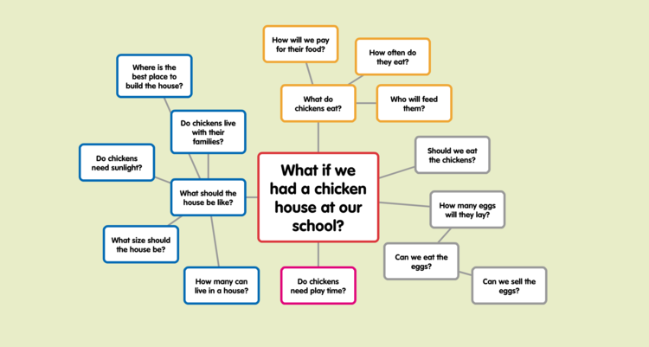

Free mind mapping apps you might consider…

- Web: Popplet, Lucidchart, Slatebox
- Chrome: Google Drawings, MindMup
- iOS: Popplet, Idea Sketch, SharpMindMap, WeMap
- Mac: SimpleMind Free, NovaMind
- Windows: NovaMind, NextGraph

Big Deal
A driving question guides a project, which can take days, weeks, or months to complete. It’s a big deal. You want to make sure your question is a good one.

